1. 
2. 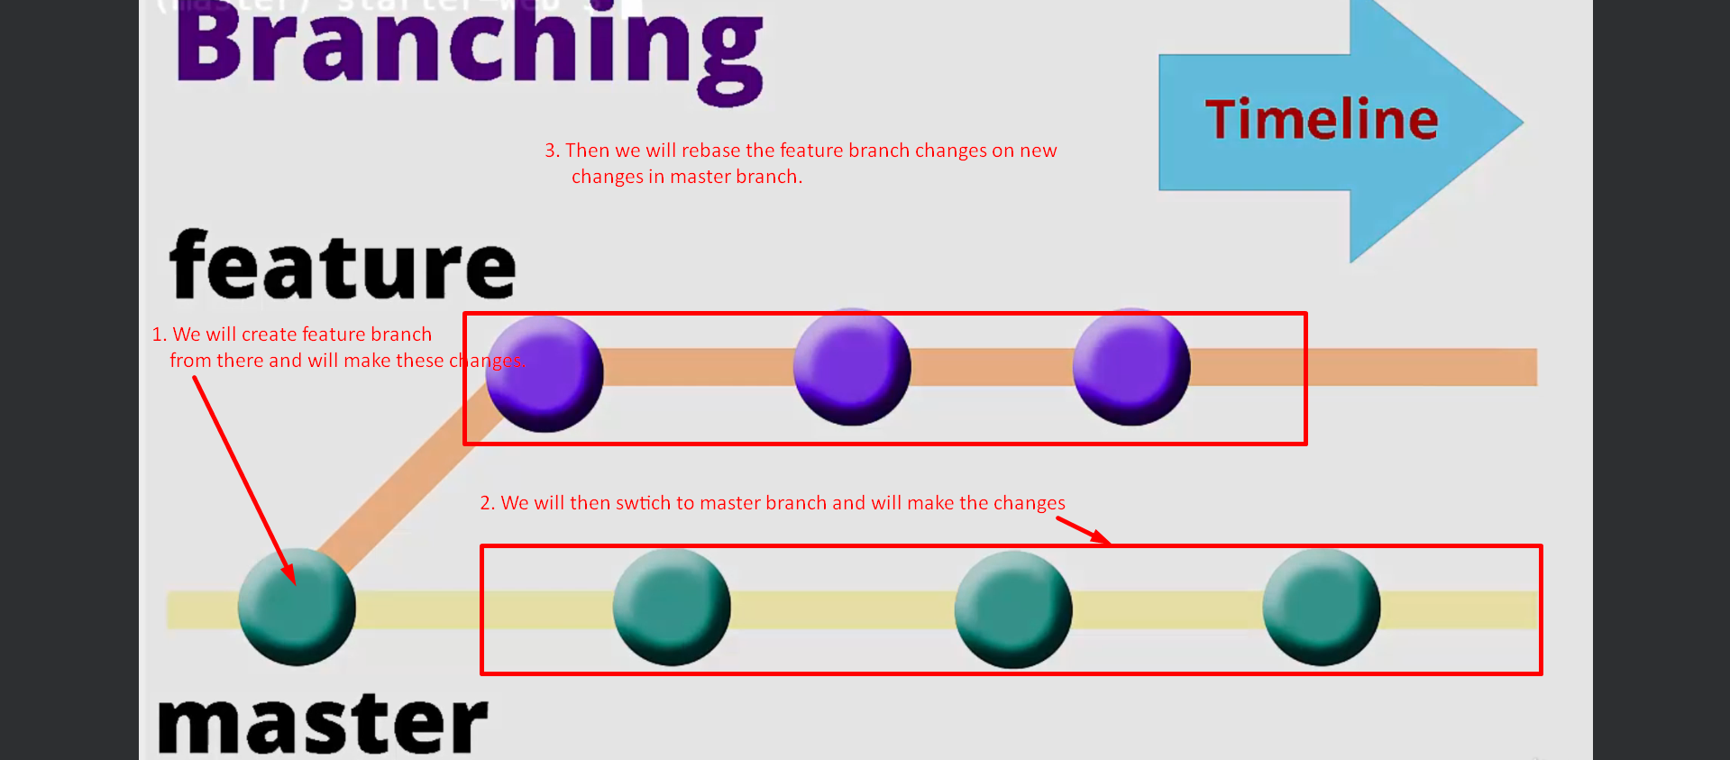
3. 
4. Checkout master and make a new commit here.  
   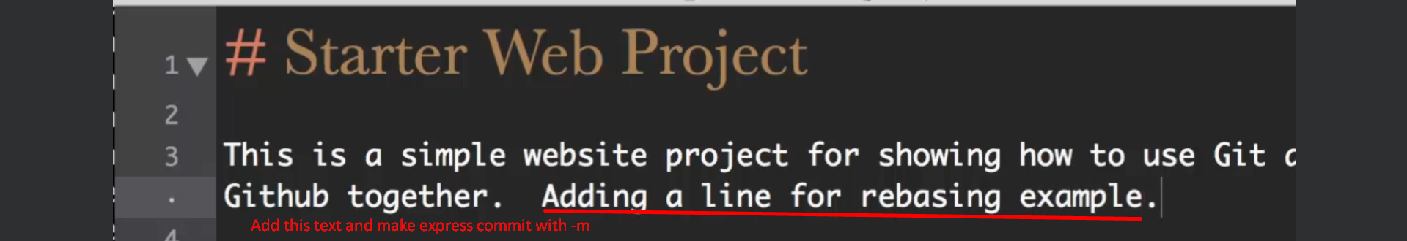
5. Let’s see graphically the structure of commit history.  
   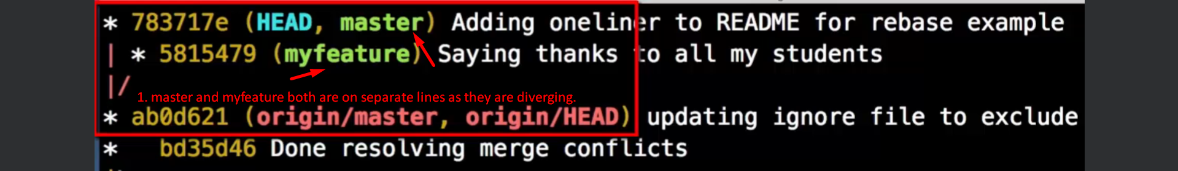
6. **Use-Case**: If we are not done with feature branch and we want to incorporate changes from master so that we don’t have massive headache when we merge feature branch **myfeature** into master later.
7. 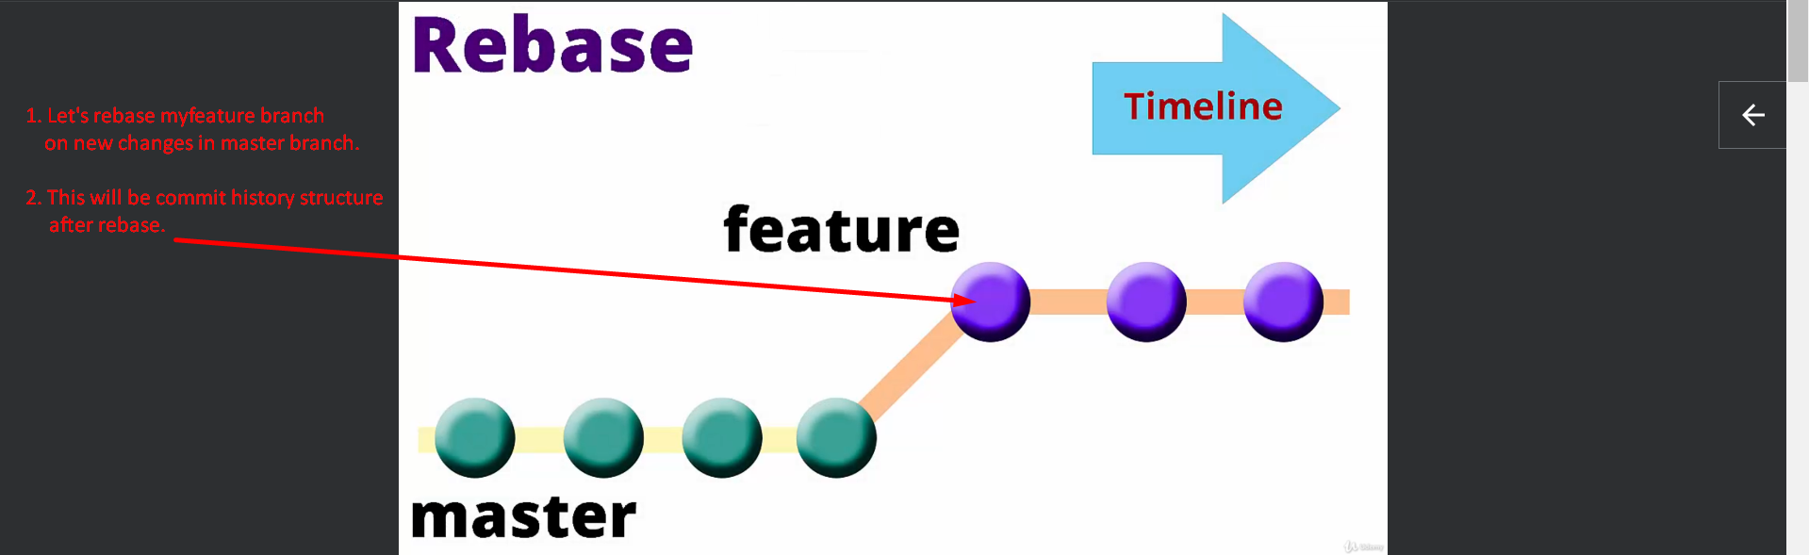
8. 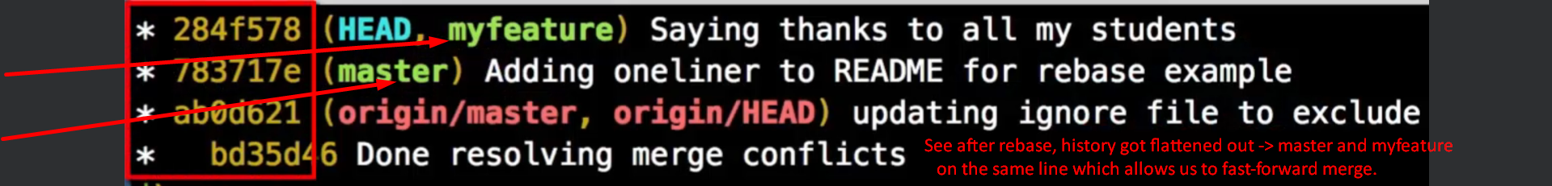
9. Let’s make one more commit in myfeature branch.  
   
10. We are done with myfeature and let’s merge myfeature into master.
11. Checkout master branch to merge myfeature.  
    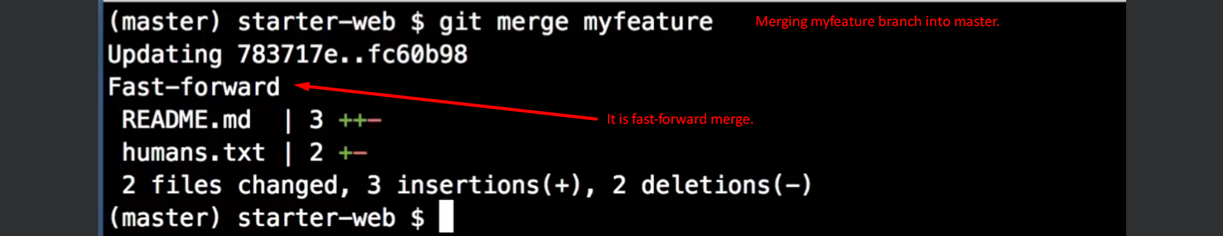
12. 